Killer robots? Musk and Zuckerberg escalate row over dangers of AI

Musk described the Facebook CEO’s knowledge of the field as ‘limited’ after Zuckerberg publicly dismissed AI doomsday warnings as ‘irresponsible’

[[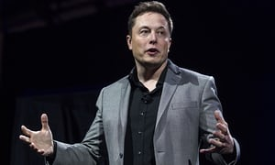](https://www.theguardian.com/technology/2017/jul/25/elon-musk-mark-zuckerberg-artificial-intelligence-facebook-tesla#img-1)](https://www.theguardian.com/technology/2017/jul/25/elon-musk-mark-zuckerberg-artificial-intelligence-facebook-tesla" \l "img-1)

*Elon Musk. The Tesla and SpaceX CEO believes artificial intelligence poses a “fundamental risk to the existence of civilization”. Photograph: Ringo HW Chiu/AP*

[**Olivia Solon**](https://www.theguardian.com/profile/olivia-solon)**in San Francisco**

Tuesday 25 July 2017 18.29

Tech billionaires Elon Musk and [Mark Zuckerberg](https://www.theguardian.com/technology/mark-zuckerberg) have entered into a public squabble about artificial intelligence in which Musk described the Facebook CEO’s knowledge of the field as “limited”.

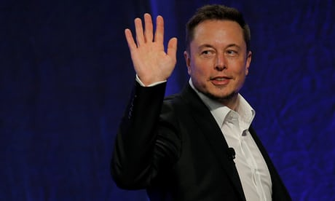

**Elon Musk: regulate AI to combat 'existential threat' before it's too late**

The groundwork for the world’s nerdiest fight was laid by Musk, the Tesla and SpaceX CEO, earlier this month, when he pushed again for the [proactive regulation of artificial intelligence](https://www.theguardian.com/technology/2017/jul/17/elon-musk-regulation-ai-combat-existential-threat-tesla-spacex-ceo) because he believes it poses a “fundamental risk to the existence of civilization”.

Musk told a gathering of US governors this month that the potential dangers are not so imaginary, and that they should move to regulate AI.

“I keep sounding the alarm bell, but until people see robots going down the street killing people, they don’t know how to react, because it seems so ethereal,” he said.

Musk, who has been issuing warnings like these for years now, is concerned that humans will become [second-class citizens](https://www.theguardian.com/technology/2017/feb/15/elon-musk-cyborgs-robots-artificial-intelligence-is-he-right) in a future dominated by artificial intelligence – or that [we’ll face a Terminator-style robot uprising](https://www.theguardian.com/technology/2014/jun/18/elon-musk-deepmind-ai-tesla-motors).

Enter Zuckerberg, who on Sunday denounced these types of warnings as “pretty irresponsible”.

Zuckerberg made the comments [while taking questions](https://www.bizjournals.com/sanjose/news/2017/07/24/elon-musk-artificial-intelligence-risk-zuckerberg.html) during a [Facebook Live](https://www.facebook.com/zuck/videos/10103911836230631/)broadcast from his Palo Alto home. One viewer asked: “I watched a recent interview with Elon Musk and his largest fear for the future was AI. What are your thoughts on AI and how could it affect the world?”

In an uncharacteristically candid response, Zuckerberg said: “I have pretty strong opinions on this. I am optimistic. And I think people who are naysayers and try to drum up these doomsday scenarios – I just, I don’t understand it. It’s really negative and in some ways I actually think it is pretty irresponsible.”

Zuckerberg believes that AI will have much less dystopian applications, and will be responsible for saving lives through disease diagnosis and by powering driverless cars.

“One of the top causes of death for people is car accidents, still, and if you can eliminate that with AI, that is going to be just a dramatic improvement,” he said.

A day later, Musk had a comeback on Twitter: “I’ve talked to Mark about this. His understanding of the subject is limited.”

It’s not the first time Musk and Zuckerberg have had a public beef. Last September, SpaceX was scheduled to launch an internet-beaming satellite intended for use by Facebook’s Free Basics project in Africa. However, the Falcon 9 rocket exploded, [destroying both the rocket and cargo](https://www.theguardian.com/science/2016/sep/01/mark-zuckerberg-spacex-explosion-africa-internet): the AMOS-6 satellite that Facebook planned to use to deliver internet connectivity to rural parts of Africa.

Zuckerberg was not happy. Writing on his [Facebook](https://www.theguardian.com/technology/facebook) page, he said: “As I’m here in Africa, I’m deeply disappointed to hear that SpaceX’s launch failure destroyed our satellite that would have provided connectivity to so many entrepreneurs and everyone else across the continent.”

First depriving African entrepreneurs of internet access, and now dissing Zuck’s intellect, Musk has drawn the battle lines. Your move, Mark.